Protocol # | Description | Objective | Reqt/Spec | Author
WIA- | Login | To verify user login authentication.  In this test case, login authentication will be tested along with verification of mandatory fields.

Prerequisites | - Standard System Configuration  - User login exists and is configured for Title21 authentication.  - User must not be signed in (to the Web Interface)
Procedure | - Enter the URL in the browser to bring up the web interface login page.  - Click on Log in button without a user name.  ER 1 – User is informed of missing User Name    - Enter a valid user name for a user within in the system, click on Log in button.  - Click on Log in button without password.  ER 2 – User is informed of missing Password    - Enter an incorrect password, and click on Log in button.  ER 3 – Password entered is cleared and user is informed of invalid credentials    - Enter the correct user name and password.    ER 4 – User is successfully logged in and the home screen or dashboard is displayed  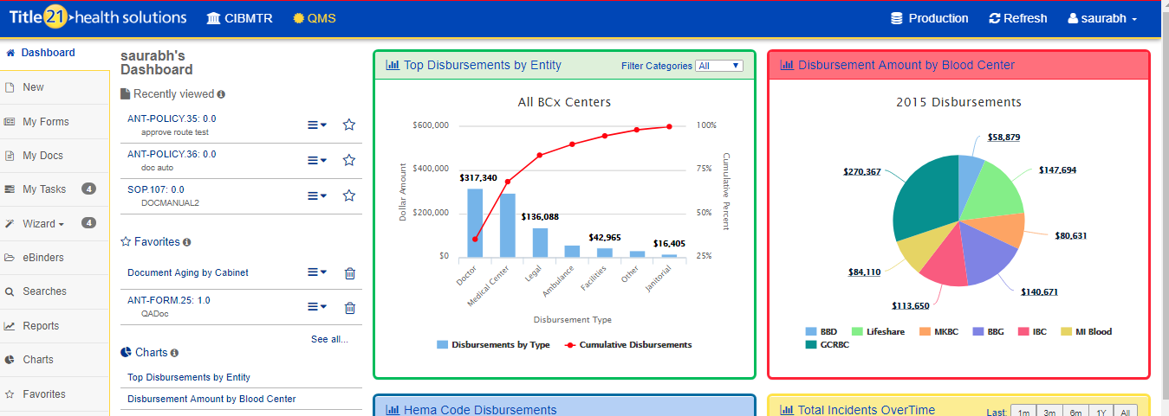
Pass/Fail | Pass:  Fail: | Type of Execution:
Pass/Fail | Pass:  Fail: | Automation: | Manual:
Notes/Deviations
Additional Remarks in case of Manual Execution
Name of Tester(if Manual)
Test Case Review/Approval | Signature of  Reviewer/Approver: |  |  | Date of Approval:

